CS4335 Tutorial 6 (dynamic programming
Name: Student ID:

Q1: Given 8 jobs with the following (v, s, f)-values (v=value, s= start time, and f= finish times):
a=(3.5,0,6), b=(2,1,4), c=(3,3,5), d=(3,3,8), e=(6.5,4,7), f=(2.5,5,9), g=(12,6,10), h=(8,8,11).
Find a set of mutually compatible jobs with the maximal total value.

Q2. Find the longest route from upper left to lower right, using the diagonal streets if it helps
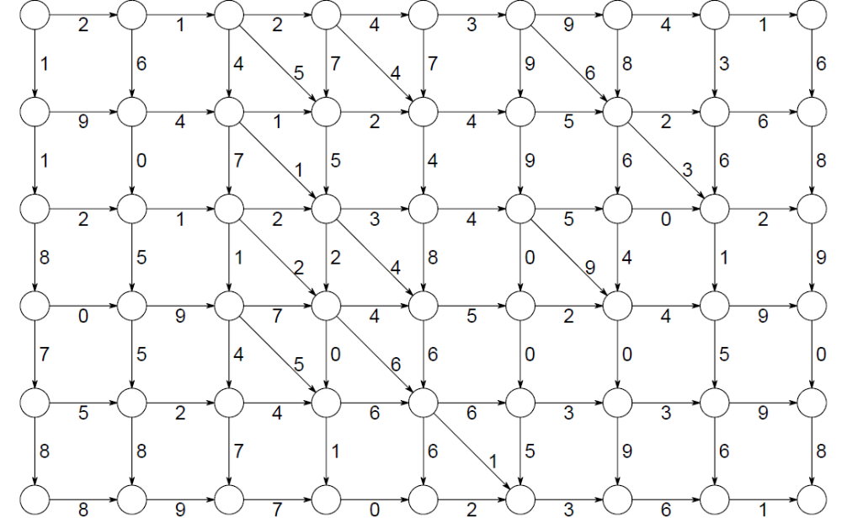Q1：
Start Time: a(0, 6), b(1,4), c(3,5), d(3,8),e(4,7), f(5,9), g(6, 10), h(8, 11)
Finish time: b(1, 4), c(3,5), a(0,, 6), e(4,7), d(3,8), f(5,9), g(6, 10), h(8, 11)
p(h)=d, p(g)=a, p(f)=c, p(e)=b, p(d)=0, p( c )=0, p(b)=0, p(a)=0.

b c a e d f g h
i 0 1 2 3 4 5 6 7 8
M 0.0 2.0 3.0 3.5 8.5 8.5 8.5 12.0+3.5(15.5) 8.0+8.5=16.5
B 0 1 1 1 1 0 0 1 1

Backtracking: h, e, b
8.0 6.5 2
Q2: NOT required.

